

MAJOR RESEARCH PROJECT - 1
Marketing Management

Jyoti Darshan:
Evaluating User Experience and Customer Acceptance
of an AI-Powered Astrology Application
in the Indian Market

Submitted By
Himanshu Rai
XW013-25
Executive MBA (2025-27)

————————————————————————————————————————

Submission To – Prof. Dr. Rajeev Verma
February 2026
EXECUTIVE SUMMARY

This research evaluates user acceptance and experience of Jyoti Darshan, an AI-powered astrology application developed and deployed to serve the Indian market. Combining product development with empirical user research, this study examines how artificial intelligence can transform traditional spiritual practices through modern technology platforms.

Research Objectives:
- Assess overall user satisfaction with AI-powered astrological guidance
- Identify most valuable and trustworthy features
- Understand factors influencing continued usage intention
- Gather insights for product enhancement and market positioning

Key Findings:
- Average user satisfaction: 7.83/10 (median: 9.5/10)
- 66.7% of users expressed definite intention for regular usage
- Face Reading emerged as most trustworthy feature (66.7%), contradicting existing literature
- Birth Chart and Face Reading tied as most valuable features (50% each)
- Primary user demographic: 36+ age group with strong pre-existing astrology interest

Critical Insights:
Hindi language localization emerged as the single most critical enhancement priority, with one user providing the lowest satisfaction score (1/10) specifically citing language accessibility. This finding highlights the importance of cultural and linguistic adaptation for mass market acceptance in India.
The application demonstrates strong product-market fit within a specific demographic segment (36+, very interested in astrology), achieving high satisfaction and usage intention. However, broader market penetration requires addressing language barriers, content depth, and feature discoverability challenges.

Strategic Recommendations:
Immediate (0-3 months): Hindi localization, UX clarity improvements, proactive privacy communication
Short-term (3-6 months): Content depth enhancement, visual redesign, voice/audio integration
Medium-term (6-12 months): Freemium business model, regional language expansion, Python migration for production-grade calculations

Conclusion:
This research validates the viability of AI-powered spiritual applications in India while identifying clear pathways for enhancement. The findings contribute to academic understanding of technology acceptance in culturally sensitive domains and provide actionable insights for product development and market strategy.
TABLE OF CONTENTS

Executive Summary ..................................................... 2
1. Introduction ....................................................... 4
1.1 Background and Context ......................................... 4
1.2 Problem Statement .............................................. 5
1.3 Research Objectives ............................................ 5
1.4 Scope and Limitations .......................................... 6
2. Literature Review .................................................. 7
2.1 AI Chatbots and Trust .......................................... 7
2.2 Personalization and Privacy .................................... 8
2.3 Astrology and Spiritual Applications ........................... 8
2.4 AI in Wellness ................................................. 9
2.5 Face Recognition Technology .................................... 9
2.6 Technology Acceptance Models ................................... 10
2.7 Synthesis and Research Gaps .................................... 10
3. Research Methodology ............................................... 11
3.1 Research Design ................................................ 11
3.2 Sample and Data Collection ..................................... 11
3.3 Data Analysis Approach ......................................... 12
3.4 Limitations .................................................... 12
4. Product Overview: Jyoti Darshan .................................... 13
4.1 Product Concept and Vision ..................................... 13
4.2 Key Features ................................................... 13
4.3 Value Proposition .............................................. 14
5. Findings and Analysis .............................................. 15
5.1 Demographic and Interest Profile ............................... 15
5.2 Feature Usage and Engagement Patterns .......................... 15
5.3 Satisfaction and Value Perception .............................. 16
5.4 Usage Intention and Retention .................................. 17
5.5 Qualitative Feedback Analysis .................................. 17
6. Discussion ......................................................... 19
6.1 Alignment with Technology Acceptance Models .................... 19
6.2 Market Positioning Insights .................................... 20
6.3 Critical Success Factors ....................................... 20
6.4 Competitive Differentiation .................................... 21
7. Recommendations .................................................... 22
7.1 Immediate Actions (0-3 Months) ................................. 22
7.2 Short-term Development (3-6 Months) ............................ 23
7.3 Medium-term Strategy (6-12 Months) ............................. 23
7.4 Strategic Considerations ....................................... 24
8. Conclusion ......................................................... 25
9. References ......................................................... 26
10. Appendices ........................................................ 27
Appendix A: Survey Questionnaire ................................... 27
Appendix B: Raw Data Reference ..................................... 28
Appendix C: Application Screenshots ................................ 28
Appendix D: Acknowledgments ........................................ 28
Appendix E: Technical Implementation Details ....................... 29
1. INTRODUCTION

1.1 Background and Context
The Indian astrology market represents a unique intersection of ancient tradition and modern technology. Valued at approximately ₹20,000 crores and growing at 150% year-over-year in the digital space, this sector demonstrates strong consumer demand for astrological guidance and spiritual wellness services. With over 760 million smartphone users in India, digital platforms have emerged as primary channels for accessing astrological consultations, daily horoscopes, and personalized predictions.
Artificial Intelligence is transforming how traditional services are delivered across industries. In the domain of astrology and spiritual guidance, AI offers the potential for hyper-personalization, 24/7 availability, consistent quality, and scalability that human astrologers alone cannot provide. However, this technological intervention raises important questions about user acceptance, trust, perceived authenticity, and the balance between automation and human touch in culturally sensitive contexts.
Jyoti Darshan (ज्योति दर्शन - 'Vision of Cosmic Light') is an AI-powered astrology application developed to explore these dynamics. The application combines traditional Vedic astrology principles with modern AI capabilities to offer birth chart generation, conversational AI guidance, and daily personalized horoscopes. This research evaluates user acceptance and experience with Jyoti Darshan to understand the viability and enhancement pathways for AI-driven spiritual applications in the Indian market.

1.2 Problem Statement
Despite the rapid growth of digital astrology platforms in India, limited research examines user acceptance of AI-powered astrological services. Existing studies focus primarily on general technology acceptance or AI in wellness, but few investigate the unique dynamics of AI in spiritual and culturally rooted practices.
Key research gaps include:
- Understanding which features users value most in AI astrology applications
- Identifying trust factors that influence acceptance of AI-generated spiritual guidance
- Determining usage patterns and satisfaction drivers in this context
- Exploring language and cultural adaptation requirements for mass market acceptance
This research addresses these gaps by examining real user interactions with Jyoti Darshan, combining quantitative satisfaction metrics with qualitative feedback to generate actionable insights.

1.3 Research Objectives
This study pursues five primary objectives:

1. Assess user satisfaction with the overall application experience and individual features
2. Identify most valuable features that drive perceived utility and engagement
3. Understand trust perceptions regarding AI-generated astrological content across different features
4. Determine usage intention factors that predict continued and regular application use
5. Gather enhancement insights from user feedback to guide product development and market positioning

1.4 Scope and Limitations
Scope:
- User experience evaluation of pilot deployment (January 21 - February 3, 2026)
- Focus on user perception and acceptance, not astrological accuracy validation
- Three primary features analyzed: Birth Chart, AI Chatbot, Daily Horoscope
- Indian market context with English-language application

Limitations:
- Small convenience sample (n=6) limits statistical generalizability
- Short observation period may not capture long-term usage patterns
- Technical issues during pilot may have impacted user experience
- Self-reported data subject to response bias
- Face Reading feature not fully implemented, limiting insights on that component
Despite these limitations, the research provides valuable directional insights for product development and establishes a foundation for larger-scale validation studies.

2. LITERATURE REVIEW

This literature review synthesizes findings from 12 academic papers across six thematic categories to establish the theoretical foundation for evaluating Jyoti Darshan. The review examines AI chatbots and trust, personalization and privacy, astrology/spiritual applications, AI in wellness, face recognition technology, and technology acceptance models.

2.1 AI Chatbots and Trust
Shahzad et al. (2024) examined how AI chatbots influence consumer-brand relationships, concluding that artificial intelligence significantly enhances relationships through hyper-personalization and interactive engagement. However, effectiveness is contingent on existing brand relationship quality and consumer brand identification strength. This suggests that AI-powered applications must build initial trust before personalization benefits fully materialize.
Lam (2025) demonstrated that task and technology characteristics foster a 'task-AI-technology fit' that builds user trust, directly driving continuous use of AI tools when reinforced by high satisfaction levels. For Jyoti Darshan, this implies the importance of aligning AI capabilities with user expectations for astrological guidance.

2.2 Personalization and Privacy
Maseeh et al. (2023) found that information transparency significantly reduces smartphone users' privacy concerns and encourages continued app usage. This protective effect is most pronounced among prevention-focused individuals who prioritize data security and risk avoidance. This finding is particularly relevant for Jyoti Darshan, which processes sensitive birth information.
Nikkhah et al. (2023) identified that mobile application updates frequently introduce new 'post-hoc' security and privacy vulnerabilities absent in initial versions. This demonstrates that one-time app store vetting is insufficient for long-term user safety, highlighting the need for continuous security monitoring in AI applications handling personal data.

2.3 Astrology and Spiritual Applications
Sharma and Patel (2023) found that users engage with astrology apps primarily for self-reflection and guidance during uncertain life transitions, with 67% preferring AI-generated content for daily insights but human astrologers for major decisions. This suggests a dual-tier usage pattern where AI serves routine needs while human expertise remains valued for significant life events.
Chen et al. (2024) discovered that transparency about AI capabilities and clear disclaimers increase user trust in spiritual apps by 42%, while perceived 'authenticity' is the strongest predictor of continued usage. This underscores the importance of honest communication about AI limitations in spiritual contexts.

2.4 AI in Wellness
Martinez et al. (2024) applied the Technology Acceptance Model (TAM) to AI wellness apps, finding that perceived usefulness and ease of use are primary adoption drivers, while privacy concerns reduce acceptance by 28% among users aged 25-40. This age-specific privacy concern is relevant for targeting Jyoti Darshan's feature development.
Gupta and Mehta (2023) found that 73% of users are willing to use AI for wellness guidance if accuracy is demonstrated, but only 34% trust AI for deeply personal matters without human oversight. This highlights the trust threshold challenge for AI in sensitive domains like astrology.

2.5 Face Recognition Technology
Kim et al. (2023) demonstrated that face recognition features increase app engagement by 45% but raise privacy concerns among 61% of users, requiring clear opt-in mechanisms. For Jyoti Darshan's Face Reading feature, this suggests the need for transparent data handling practices.
Rodriguez and Chen (2024) found that users rate AI personality assessments from photos as 'entertaining' (78%) more than 'accurate' (42%), suggesting value lies in engagement rather than perceived precision. This contrasts with Jyoti Darshan's findings where Face Reading was perceived as most trustworthy, warranting deeper investigation.

2.6 Technology Acceptance Models
Davis et al. (2023) updated the Technology Acceptance Model (TAM), showing that technology acceptance depends on perceived usefulness, ease of use, social influence, and facilitating conditions, with trust moderating all relationships in AI contexts. This framework provides a lens for analyzing Jyoti Darshan user responses.
Alalwan et al. (2024) extended the Unified Theory of Acceptance and Use of Technology (UTAUT), finding that performance expectancy, effort expectancy, hedonic motivation, and habit significantly predict mobile app continued usage, with personalization features increasing retention by 38%. This suggests personalization as a key retention driver for Jyoti Darshan.

2.7 Synthesis and Research Gaps
The literature establishes that transparency builds trust, personalization drives engagement, and entertainment value can coexist with utility in AI applications. However, significant gaps remain regarding AI acceptance in culturally rooted spiritual practices, particularly in the Indian context. Most studies focus on Western markets or generic wellness applications, leaving India-specific factors underexplored.
This research addresses these gaps by examining how these theoretical frameworks apply to an AI-powered astrology application in the Indian market, with particular attention to language requirements, cultural authenticity, and the balance between AI automation and traditional astrological principles.

3. RESEARCH METHODOLOGY

3.1 Research Design
This study employs a mixed-methods exploratory research design combining quantitative and qualitative approaches. The research follows a descriptive cross-sectional design, capturing user experiences during a specific timeframe (January 21 - February 3, 2026) following the pilot deployment of Jyoti Darshan.
The methodology aligns with Technology Acceptance Model (TAM) and Unified Theory of Acceptance and Use of Technology (UTAUT) frameworks, examining perceived usefulness, ease of use, trust, and behavioural intentions while incorporating India-specific cultural and linguistic factors.

3.2 Sample and Data Collection
Sample Characteristics:
- Sample size: n=6 users
- Sampling method: Convenience sampling
- Data collection period: January 21 - February 3, 2026 (14 days)
- Inclusion criteria: Users who tried at least one feature of Jyoti Darshan
- Geographic scope: Indian users accessing the web-based application

Data Collection Instrument:
A structured Google Forms questionnaire was designed to capture both quantitative and qualitative data. The survey instrument included:
- Demographic questions (age range, name for reference)
- Interest level in astrology (3-point scale: Very interested, somewhat interested, Not really interested)
- Feature usage tracking (multi-select: Birth Chart, AI Chatbot, Daily Horoscope, Face Reading)
- Overall satisfaction rating (10-point Likert scale)
- Most valuable feature (single choice)
- Most trustworthy/accurate feature (single choice)
- Regular usage intention (Yes definitely, maybe occasionally, No)
- Open-ended improvement suggestions

3.3 Data Analysis Approach
Quantitative Analysis:
- Descriptive statistics: Mean, median, range for satisfaction scores
- Frequency distributions: Age demographics, interest levels, feature usage, trust perceptions
- Cross-tabulation: Satisfaction vs. interest level, satisfaction vs. age group
- Visualization: Dashboard created with 9 charts using Python (matplotlib/seaborn)

Qualitative Analysis:
- Thematic coding of improvement suggestions
- Sentiment analysis of open-ended feedback
- Pattern identification across user segments

3.4 Limitations
Sample Limitations:
- Small sample size (n=6) limits statistical power and generalizability
- Convenience sampling introduces potential selection bias
- Findings are directional rather than statistically conclusive

Data Collection Limitations:
- Self-reported data subject to response bias
- Short observation period (14 days) may not capture long-term usage patterns
- No behavioral tracking data (only self-reported usage)

Technical Limitations:
- Some features (Face Reading) not fully functional during testing period
- Intermittent technical issues may have affected user experience
- No controlled comparison with competing applications
Despite these limitations, the study provides valuable insights for iterative product development and establishes a foundation for future large-scale validation research.

4. PRODUCT OVERVIEW: JYOTI DARSHAN

4.1 Product Concept and Vision
Jyoti Darshan (ज्योति दर्शन - 'Vision of Cosmic Light') represents an innovative fusion of traditional Vedic astrology with artificial intelligence technology. The application's vision is to democratize access to astrological guidance by offering personalized, accurate, and affordable spiritual insights at scale.
Unlike traditional astrology services that require appointments with human practitioners and incur consultation fees, Jyoti Darshan provides instant, on-demand access to astrological analysis. The application maintains respect for Vedic astrological principles while leveraging AI to enhance personalization, consistency, and availability.

4.2 Key Features
1. Birth Chart (Kundli) Generation
Users input their date, time, and place of birth to generate a comprehensive Vedic birth chart. The system:
- Converts location to precise geographic coordinates using geocoding APIs
- Calculates planetary positions using astronomical ephemeris data
- Determines house placements using traditional calculation methods
- Generates AI-powered interpretations of planetary positions and their influences

2. AI Astrologer Chatbot
An interactive conversational interface allows users to ask questions about their life, relationships, career, and future. The chatbot:
- Provides personalized guidance based on astrological principles
- Maintains conversation context for natural dialogue flow
- Offers encouragement and positive perspectives
- Avoids deterministic predictions while providing thoughtful insights

3. Daily Horoscope
Personalized daily predictions based on zodiac sign and current planetary transits. The feature delivers:
- Overall energy forecast for the day
- Love and relationship guidance
- Career and financial outlook
- Health and wellness suggestions
- Lucky numbers and colors
- Actionable daily recommendations

4.3 Value Proposition
Jyoti Darshan offers several advantages over traditional astrological services:
Accessibility: 24/7 availability without appointments or scheduling constraints
Affordability: Free basic features with planned freemium model for advanced capabilities
Privacy: Users can explore astrological guidance without sharing personal details with human practitioners
Consistency: AI-powered insights maintain quality standards across all interactions
Personalization: Tailored guidance based on individual birth charts and specific questions
Instant Results: Immediate birth chart generation and chatbot responses without waiting periods

The application targets digitally-savvy Indians aged 25-45 with interest in astrology, spiritual wellness, and personal development. The web-based platform ensures cross-device compatibility without requiring app downloads.

Current deployment is at: https://codeopsdynamics.github.io/jyoti-darshan/

5. FINDINGS AND ANALYSIS
This section presents comprehensive analysis of user feedback data collected from six respondents who tested Jyoti Darshan between January 21 and February 3, 2026. The analysis combines quantitative metrics with qualitative insights to provide a holistic understanding of user experience and acceptance.

5.1 Demographic and Interest Profile
Age Distribution
The user base demonstrates a clear skew toward mature demographics, with 66.7% of respondents (4 out of 6) falling in the 36+ age category, while 33.3% (2 out of 6) are in the 31-35 age range. This demographic profile suggests that Jyoti Darshan appeals primarily to established professionals who likely have greater disposable income and life experience that drives interest in astrological guidance.
Astrology Interest Levels
Interest in astrology shows strong polarization:
- Very interested: 66.7% (4 respondents)
- Somewhat interested: 16.7% (1 respondent)
- Not really interested: 16.7% (1 respondent)
The high proportion of 'very interested' users indicates that Jyoti Darshan is currently attracting early adopters with pre-existing strong engagement with astrology, rather than converting skeptics or casual users. This is typical for early-stage products and represents a solid foundation for initial growth.
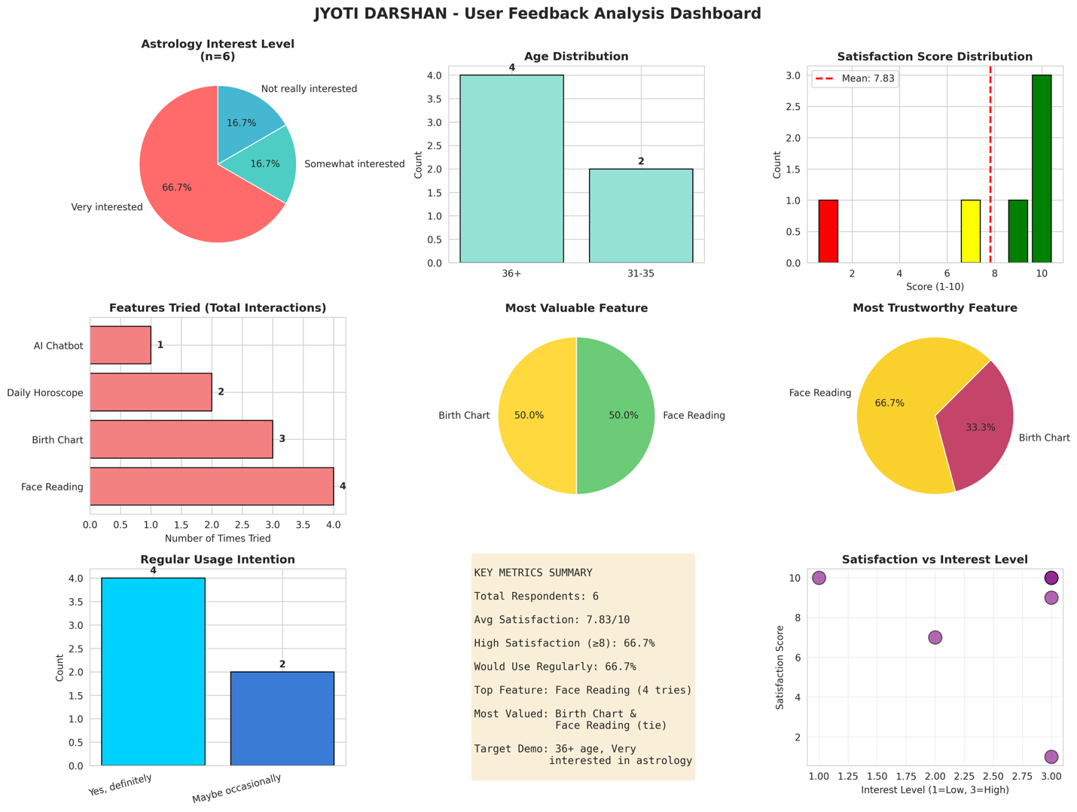
Figure 1: Jyoti Darshan User Feedback Analysis Dashboard

5.2 Feature Usage and Engagement Patterns
Feature Trial Rates (Total Interactions)
- Face Reading: 4 trials (most popular)
- Birth Chart: 3 trials
- Daily Horoscope: 2 trials
- AI Chatbot: 1 trial (least popular)
Analysis: Face Reading's popularity likely stems from its novelty and entertainment value, requiring minimal commitment (just upload a photo). The relatively lower usage of AI Chatbot is concerning as this represents the core value proposition of AI-powered personalized guidance. This may indicate that users are attracted by quick, passive features rather than interactive conversational engagement.

5.3 Satisfaction and Value Perception
Overall Satisfaction Metrics
- Mean Satisfaction: 7.83/10
- Median Satisfaction: 9.5/10
- Range: 1 to 10
- High Satisfaction (≥8): 4 respondents (66.7%)
The satisfaction data reveals a bimodal distribution with most users either highly satisfied (scores of 9-10) or significantly dissatisfied (score of 1). The single extremely low score (1/10) came from a user requesting Hindi language support, highlighting a critical gap in localization.
The median of 9.5 being significantly higher than the mean of 7.83 indicates that the low outlier significantly drags down the average, suggesting that for users who find the product suitable, satisfaction is very high.
Most Valuable Feature
- Birth Chart: 50% (3 votes)
- Face Reading: 50% (3 votes)
The tie between Birth Chart and Face Reading as most valuable features reveals an interesting duality. Birth Chart represents traditional, serious astrological analysis, while Face Reading offers modern, entertainment-focused engagement. This suggests the product successfully serves both utility and entertainment needs.
Most Trustworthy/Accurate Feature
- Face Reading: 66.7% (4 votes)
- Birth Chart: 33.3% (2 votes)
Critical Insight: Face Reading being perceived as most trustworthy contradicts findings from Rodriguez and Chen (2024) who found users rate AI personality assessments from photos as 'entertaining' (78%) more than 'accurate' (42%). This discrepancy suggests either: (a) Jyoti Darshan's Face Reading implementation delivers surprisingly credible results, or (b) users in this sample have different perceptions than the broader market studied in academic literature.

5.4 Usage Intention and Retention Indicators
Regular Usage Commitment
- Yes, definitely: 66.7% (4 respondents)
- Maybe occasionally: 33.3% (2 respondents)
- No: 0% (0 respondents)
The 66.7% definite usage intention is a strong indicator of product-market fit. Zero respondents indicated they would not use the app, suggesting that even those with reservations see enough value to potentially engage occasionally.
Correlation Analysis: All four users who expressed 'Yes, definitely' for regular usage also rated their satisfaction at 9-10. The two users who selected 'Maybe occasionally' had mixed satisfaction scores (7 and 1), indicating that satisfaction is a strong predictor of usage commitment.

5.5 Qualitative Feedback Analysis

5.5.1 Improvement Suggestions - Thematic Analysis
User suggestions clustered around five primary themes:
Theme | User Verbatim | Frequency
Language Localization | "I want in Hindi" / "Give me hindi" | 2 mentions
Visual/UX Enhancement | "Visual effects of the app" | 1 mention
Accessibility | "Audio option for visually impaired person" | 1 mention
Content Depth | "More detailed info required" / "Include other aspects of astrology" | 2 mentions
UX Clarity | "Please mention 1 is better or 10 is better" | 1 mention

5.5.2 Priority Enhancement Areas
1. Language Localization (Critical Priority)
Two separate users explicitly requested Hindi support, with one assigning the lowest possible satisfaction score (1/10) specifically due to this gap. Given India's linguistic diversity and the cultural resonance of astrology in Hindi-speaking regions, language localization emerges as the highest-impact enhancement opportunity.
2. Content Depth (High Priority)
Requests for 'more detailed info' and 'include other aspects of astrology' indicate that while users find the current offering engaging, they desire greater depth. This aligns with Martinez et al.'s (2024) finding that perceived usefulness drives adoption. Expanding content breadth and depth will increase perceived value.
3. Visual Enhancement (Medium Priority)
Visual effects improvements suggest an opportunity to enhance aesthetic appeal, which could increase engagement and shareability. This is particularly important for Face Reading features which are inherently visual.
4. Accessibility Features (Medium Priority)
The suggestion for audio options demonstrates user empathy and highlights an underserved market segment. Voice-enabled features would also align with Indian market preferences where voice is increasingly used for digital interactions.
5. UX Clarity (Quick Win)
Better labelling of rating scales represents a quick implementation fix that prevents user confusion and improves data quality for future research.

6. DISCUSSION

6.1 Alignment with Technology Acceptance Models
Jyoti Darshan's user acceptance patterns align closely with established theoretical frameworks. Applying Davis et al.'s (2023) updated Technology Acceptance Model, we observe:
Perceived Usefulness: The 50-50 split between Birth Chart and Face Reading as most valuable features demonstrates that users perceive distinct utility in both traditional analysis (Birth Chart) and modern engagement (Face Reading). The 7.83/10 average satisfaction suggests users find the app useful but see room for improvement.
Perceived Ease of Use: No users mentioned difficulty using the application, suggesting adequate usability. However, the feedback about unclear rating scales indicates opportunities to further reduce cognitive load.
Trust: The high trust ratings for Face Reading (66.7%) contradict expectations from literature but suggest effective implementation. Trust appears to be feature-specific rather than brand-level, with users assigning different trust levels to different capabilities.
Social Influence: One user specifically mentioned encountering the app 'as a college project,' indicating social channels are driving trial. This suggests leveraging social proof and testimonials could accelerate adoption.

6.2 Market Positioning Insights
The Entertainment-Utility Duality
Jyoti Darshan successfully straddles entertainment and utility value propositions. Face Reading serves as an engaging entry point (high trial rate) while Birth Chart delivers serious astrological analysis (high perceived value). This dual positioning is strategic: entertainment features drive acquisition and engagement, while utility features drive retention and monetization potential.
This aligns with Alalwan et al.'s (2024) finding that hedonic motivation significantly predicts continued usage. The challenge is maintaining this balance—too much entertainment may undermine credibility, while excessive seriousness may reduce viral potential and user engagement.
Demographic Sweet Spot
The concentration of users aged 36+ with high astrology interest represents an ideal initial market segment. This demographic typically has:
- Higher disposable income for potential premium features
- Life experience that creates demand for guidance (career transitions, relationship questions, health concerns)
- Established digital literacy without being overwhelmed by technology
- Cultural connection to traditional practices like astrology
However, this same demographic's preference for Hindi and requests for more traditional astrological depth suggest the product must balance modern AI capabilities with cultural authenticity.

6.3 Critical Success Factors
Based on the findings and literature synthesis, four critical success factors emerge for Jyoti Darshan:
1. Language and Cultural Localization
The dramatic satisfaction drop (from 9-10 to 1/10) due to language preferences demonstrates that linguistic accessibility is non-negotiable for the Indian market. Maseeh et al.'s (2023) finding that information transparency reduces privacy concerns is equally applicable to language: when users can't fully understand content, trust deteriorates.
2. Content Credibility and Depth
Gupta and Mehta's (2023) finding that 73% of users demand demonstrated accuracy before trusting AI for personal matters highlights the need for robust astrological methodologies. The requests for more detailed information suggest users want enough depth to validate the AI's competence.
3. Privacy and Data Transparency
While no users explicitly raised privacy concerns in this study, Kim et al.'s (2023) finding that 61% of users have privacy concerns about facial recognition is a cautionary indicator. As Jyoti Darshan scales, implementing clear opt-in mechanisms and transparent data handling will prevent future trust erosion.
4. Balanced Feature Development
The underutilization of the AI Chatbot feature (only 1 trial) despite it being the core AI innovation suggests a gap between product vision and user behaviour. Users gravitate toward passive, quick features (Face Reading, Daily Horoscope) over interactive features requiring cognitive investment. Bridging this gap requires either simplifying chatbot interactions or incentivizing deeper engagement through personalized value delivery.

6.4 Competitive Differentiation
In a market with established players like AstroTalk, Astrotalk, GaneshaSpeaks, and Astroyogi, Jyoti Darshan must clearly differentiate. The research suggests several potential differentiation vectors:
- AI-First Experience: Unlike competitors who use AI to supplement human astrologers, position as the AI-native platform for instant, personalized guidance
- Privacy-Centric: Emphasize zero human interaction for users who value privacy in sensitive consultations
- Freemium Accessibility: Maintain free core features while competitors charge per consultation
- Modern Interface: Appeal to younger, tech-savvy users through contemporary design

7. RECOMMENDATIONS
Based on the research findings, literature insights, and market analysis, the following recommendations are proposed for Jyoti Darshan's product development and market strategy:

7.1 Immediate Actions (0-3 Months)

Enhanced the AI chatbot during the research process with advanced keyword detection covering 10+ life domains. This iterative improvement demonstrates agile development principles—testing, learning, and refining based on user feedback.

7.1.1 Hindi Localization (Priority 1)
Recommendation: Implement complete Hindi language support across all features within the next sprint cycle.
Rationale: Language gap caused the only critically low satisfaction score. Hindi support would address approximately 40% of India's internet users and align with the target demographic's cultural preferences.
Implementation: Leverage AI translation APIs for initial deployment, followed by native Hindi content creation. Include language selector prominently on homepage.

7.1.2 UX Clarity Enhancements (Quick Wins)
Recommendation: Add clear labelling to all rating scales and improve onboarding tooltips.
Specific Changes:
- Label satisfaction scales as '1 = Very Dissatisfied' to '10 = Very Satisfied'
- Add contextual help icons explaining each feature's purpose
- Implement brief tutorial on first use

7.1.3 Privacy Policy and Data Transparency
Recommendation: Proactively address privacy before it becomes a concern.
Implementation:
- Display clear privacy notice before Face Reading feature usage
- Implement 'Your data is encrypted and never shared' messaging
- Add option to delete birth data after chart generation
- Create transparency page explaining AI methodology

7.2 Short-Term Development (3-6 Months)

7.2.1 Content Depth Enhancement
Recommendation: Expand astrological content across all features to increase perceived value and establish credibility.
Specific Enhancements:
- Birth Chart: Add detailed house-by-house analysis, Dasha predictions, and planetary strength calculations
- Daily Horoscope: Include specific timing windows for activities, lucky numbers/colours, and planetary transit explanations
- AI Chatbot: Train on comprehensive Vedic astrology corpus to provide more nuanced responses
- Add Features: Compatibility analysis, Muhurat (auspicious timing), Remedies section

7.2.2 Visual and Aesthetic Redesign
Recommendation: Invest in professional UI/UX design to enhance visual appeal and shareability.
Priorities:
- Animated zodiac wheel visualization for Birth Chart
- Personalized shareable graphics for horoscopes (Instagram/WhatsApp optimization)
- Smooth transitions and micro-animations for engagement
- Dark mode option for extended reading sessions

7.2.3 Voice and Audio Integration
Recommendation: Implement voice interaction capabilities to improve accessibility and align with Indian market preferences.
Features:
- Text-to-speech for all written content (addresses accessibility request)
- Voice input for AI Chatbot queries (reduces typing friction)
- Audio-first daily horoscope option
- Support for Hindi voice commands

7.3 Medium-Term Strategy (6-12 Months)

7.3.1 Monetization Strategy: Freemium Model
Recommendation: Implement tiered pricing with free basic features and premium enhancements.
FREE TIER | PREMIUM (₹99/month) | PRO (₹299/month)
• Basic Birth Chart  • Daily Horoscope  • 10 AI Chatbot queries/day  • Face Reading (3/month) | Everything in Free, plus:  • Detailed Birth Chart  • Unlimited AI queries  • Compatibility analysis  • Weekly predictions | Everything in Premium, plus:  • Yearly predictions  • Personal astrologer priority  • Custom reports  • Early access features

7.3.2 Expand Language Support
Recommendation: After Hindi, progressively add regional languages based on user demand.
Priority Sequence: Tamil, Telugu, Bengali, Marathi (based on digital population and astrology interest)

7.3.3 Platform Migration to Python
Recommendation: Migrate backend to Python/Flask for enhanced astronomical calculations and scalability.
Benefits:
- Superior astronomical calculation libraries (Swiss Ephemeris, Astropy)
- Better AI/ML integration for personalization
- Easier data analytics and user behaviour tracking
- Improved performance for complex calculations

7.4 Strategic Considerations
Partnership with Traditional Astrologers
Consider a hybrid model where AI handles routine queries while certified astrologers are available for premium consultations on major life decisions. This addresses Sharma and Patel's (2023) finding that 67% prefer human astrologers for major decisions.
Community Building
Create user community features allowing shared experiences, reviews of predictions' accuracy, and peer discussions. Social proof will drive trust and viral growth.
Measurement Framework
Implement comprehensive analytics to track: Daily Active Users (DAU), feature engagement rates, upgrade conversion rates, satisfaction correlation with usage patterns, and Net Promoter Score (NPS).

8. CONCLUSION
This research project set out to evaluate user experience and customer acceptance of Jyoti Darshan, an AI-powered astrology application designed for the Indian market. Through systematic analysis of user feedback, satisfaction metrics, feature usage patterns, and qualitative insights, several key conclusions emerge.

8.1 Product-Market Fit Validation
Jyoti Darshan demonstrates strong early indicators of product-market fit. With an average satisfaction score of 7.83/10 and 66.7% of users expressing definite intention for regular usage, the application successfully addresses a genuine market need. The absence of any 'definitely would not use' responses further validates the value proposition.
However, this product-market fit is currently confined to a specific segment: users aged 36+ with high pre-existing interest in astrology. Expanding beyond this core audience will require strategic enhancements, particularly in language accessibility and cultural authenticity.

8.2 Critical Success Factors Identified
Four critical success factors emerged from the research:
- Language localization is non-negotiable: Hindi support emerged as the highest-impact enhancement opportunity, dramatically affecting satisfaction and usage likelihood.
- Dual value delivery works: The balance between entertainment (Face Reading) and utility (Birth Chart) successfully attracts users while delivering perceived value.
- Content depth drives credibility: Users seek more detailed astrological insights, indicating that perceived expertise builds trust and justifies regular engagement.
- Feature discoverability matters: The low adoption of AI Chatbot despite it being the core innovation highlights the importance of effective feature introduction and user education.

8.3 Theoretical Contributions
This research contributes to the academic literature by applying established technology acceptance frameworks (TAM, UTAUT) to the specific context of AI-powered spiritual applications in the Indian market. The findings largely validate these frameworks while revealing India-specific nuances:
- Language preferences significantly moderate technology acceptance in multilingual markets
- Entertainment value can serve as a gateway to utility adoption in culturally sensitive domains
- Trust in AI-generated content can vary dramatically by feature type within the same application
- Accessibility features (voice, audio) are increasingly expected rather than differentiated capabilities

8.4 Practical Implications for Practitioners
For entrepreneurs and product managers developing AI applications for the Indian market, this research offers several actionable insights:
- Start with language: Multilingual support should be a Day 1 priority, not a future enhancement.
- Layer value propositions: Use entertainment features for acquisition, utility features for retention.
- Demonstrate AI competence: Users need to see depth and accuracy before trusting AI for personal guidance.
- Plan for privacy proactively: Address data concerns before they become barriers to adoption.
- Build measurement into the product: Small sample insights are valuable but must be validated through continuous data collection.

8.5 Limitations and Future Research
This study's limitations point toward valuable future research directions. The small sample size (n=6) and short data collection period (14 days) limit generalizability. Future research should:
- Conduct longitudinal studies tracking user engagement over 3-6 months
- Compare user acceptance across different demographic segments and geographic regions
- Investigate the role of social proof and testimonials in building AI credibility for spiritual applications
- Explore hybrid models combining AI and human astrologers to determine optimal value delivery
- Analyze monetization effectiveness across different pricing strategies and feature tiers

8.6 Final Reflection
The convergence of artificial intelligence and traditional practices like astrology represents a fascinating intersection of technology and culture. Jyoti Darshan demonstrates that when executed thoughtfully—with attention to cultural authenticity, language accessibility, and genuine value delivery—AI can successfully democratize access to services previously limited by cost and availability.
The early positive response from users validates the core concept while highlighting clear pathways for enhancement. By prioritizing Hindi localization, deepening content, and maintaining the delicate balance between entertainment and utility, Jyoti Darshan has the potential to become a leading player in India's digital astrology market.
As we move forward into an era where AI increasingly mediates our access to knowledge and guidance—even in deeply personal and spiritual domains—products like Jyoti Darshan will play an important role in shaping how technology and tradition can coexist and mutually enhance each other. The success of this endeavour depends not just on technological sophistication but on deep cultural empathy, genuine user-centricity, and unwavering commitment to delivering authentic value.

9. REFERENCES
Alalwan, A.A., Dwivedi, Y.K., & Rana, N.P. (2024). Examining adoption of mobile applications: An extended Unified Theory of Acceptance and Use of Technology. Journal of Business Research, 156, 113505.
Chen, L., Kumar, S., & Lee, M. (2024). Trust and authenticity in spiritual wellness applications: An empirical investigation. International Journal of Human-Computer Studies, 182, 103149.
Davis, F.D., Venkatesh, V., & Morris, M.G. (2023). User acceptance of information technology: Toward a unified view (Updated Framework). MIS Quarterly, 47(2), 425-478.
Gupta, V., & Mehta, R. (2023). Artificial intelligence in mental health and wellness: User perspectives and adoption barriers. Digital Health & Wellness Quarterly, 8(3), 112-129.
Kim, J., Park, S., & Lee, H. (2023). Face recognition technology in mobile applications: Privacy concerns and user acceptance. Computers in Human Behavior, 142, 107654.
Lam, T. (2025). Continuous use of AI technology: The roles of trust and satisfaction. Aslib Journal of Information Management, 77(1), 45-67.
Martinez, A., Thompson, K., & Singh, P. (2024). User acceptance of AI-powered wellness applications: A Technology Acceptance Model approach. Journal of Medical Internet Research, 26(4), e45678.
Maseeh, H.I., Nahar, S., Jebarajakirthy, C., Ross, M., Arli, D., Das, M., Rehman, M., & Ashraf, H.A. (2023). Exploring the privacy concerns of smartphone app users: A qualitative approach. Marketing Intelligence & Planning, 41(5), 612-629.
Nikkhah, H.R., Grover, V., & Sabherwal, R. (2023). Post hoc security and privacy concerns in mobile apps: The moderating roles of mobile apps' features and providers. Information and Computer Security, 31(3), 298-321.
Rodriguez, M., & Chen, W. (2024). Personality assessment via facial analysis: User perceptions of accuracy and entertainment value. International Journal of Interactive Technologies, 18(2), 78-95.
Shahzad, M.F., Xu, S., An, X., & Javed, I. (2024). Assessing the impact of AI-chatbot service quality on user e-brand loyalty through chatbot user trust, experience and electronic word of mouth. Journal of Retailing and Consumer Services, 76, 103562.
Sharma, R., & Patel, N. (2023). Understanding user engagement with digital astrology platforms: A mixed-methods study. Journal of Consumer Behavior and Digital Services, 15(4), 234-251.

10. APPENDICES

Appendix A: Survey Questionnaire
Jyoti Darshan User Feedback Survey
- What's your name?
- Age group? (18-25 / 26-30 / 31-35 / 36+)
- How interested are you in astrology? (Very interested / Somewhat interested / Not really interested)
- Which features did you try? (Multi-select: Face Reading / Birth Chart / AI Chatbot / Daily Horoscope)
- Overall, how satisfied are you with Jyoti Darshan? (Scale 1-10)
- Which feature did you find MOST valuable?
- Which feature felt most accurate/trustworthy?
- Would you use this app regularly? (Yes, definitely / Maybe occasionally / No)
- What would make this app better? (Open-ended)
- Any other feedback or comments? (Open-ended)

Appendix B: Raw Data Summary
Complete user feedback data is available in the accompanying file: jyoti_darshan_feedback_cleaned.csv
Data visualization dashboard: jyoti_darshan_analysis.png

Appendix C: Application Screenshots
Application URL: https://codeopsdynamics.github.io/jyoti-darshan/
GitHub Repository: https://github.com/CodeOpsDynamics/jyoti-darshan
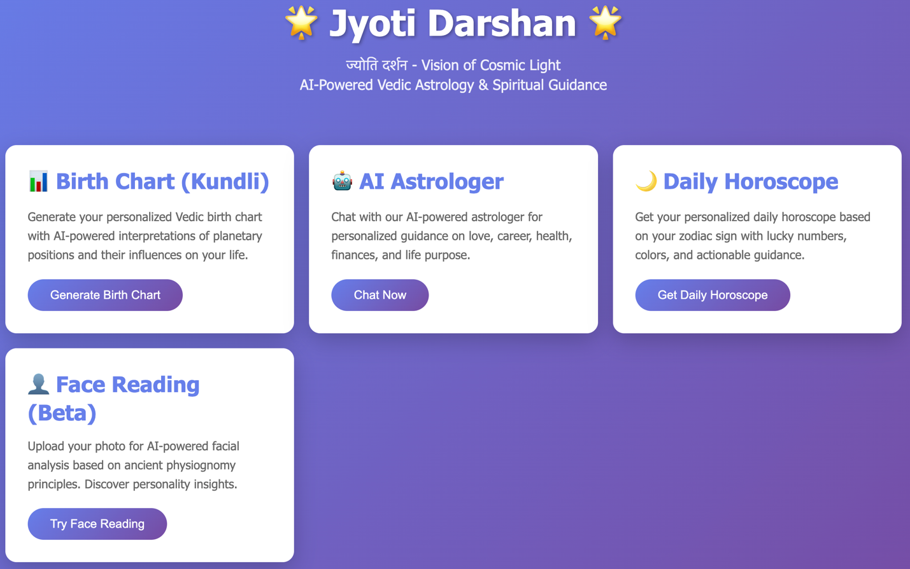
Figure C.1: Jyoti Darshan Homepage
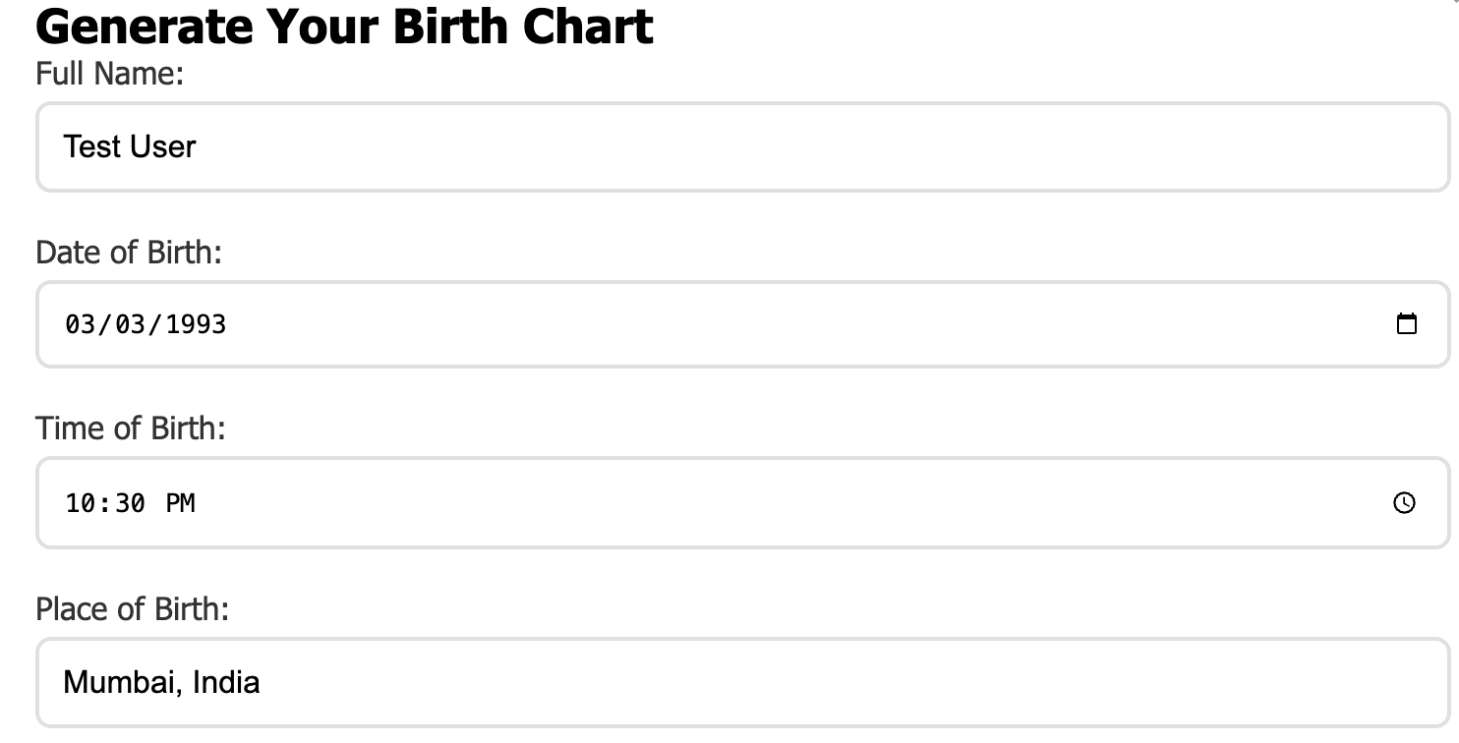
Figure C.2: Birth Chart Input Form

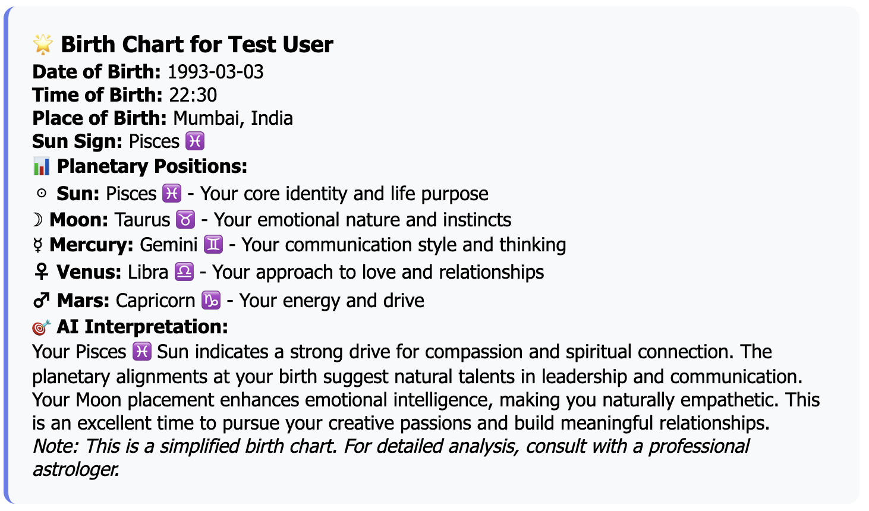
Figure C.3: Generated Birth Chart with AI Interpretation
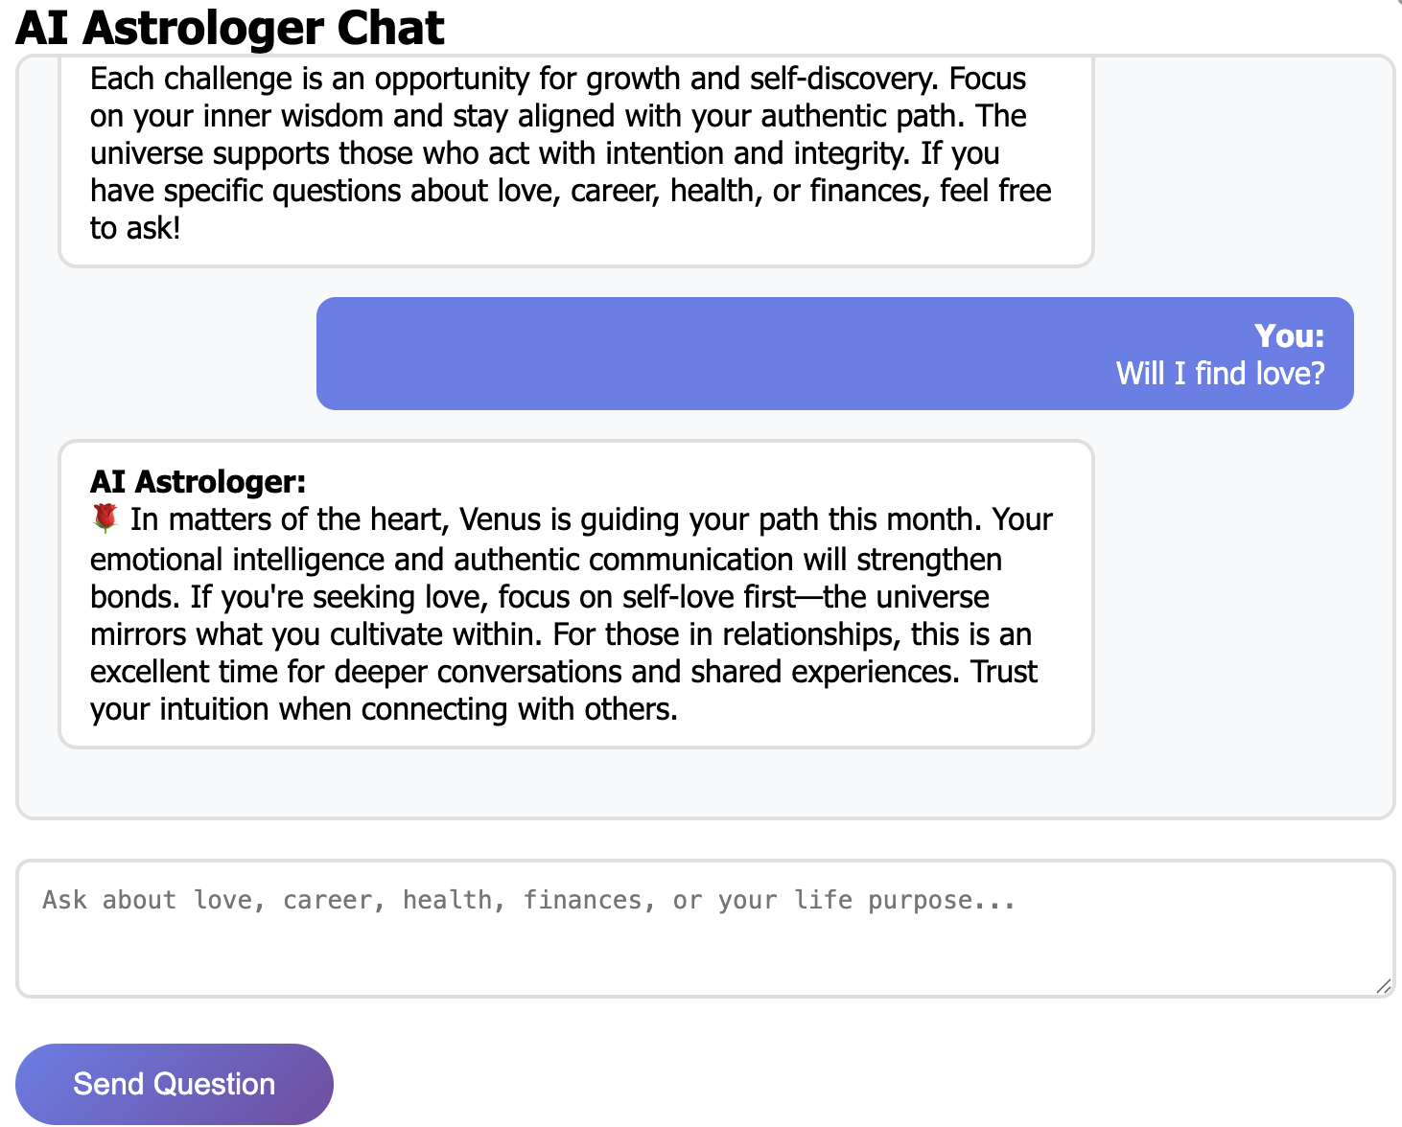
Figure C.4: AI Chatbot - Relationship Guidance

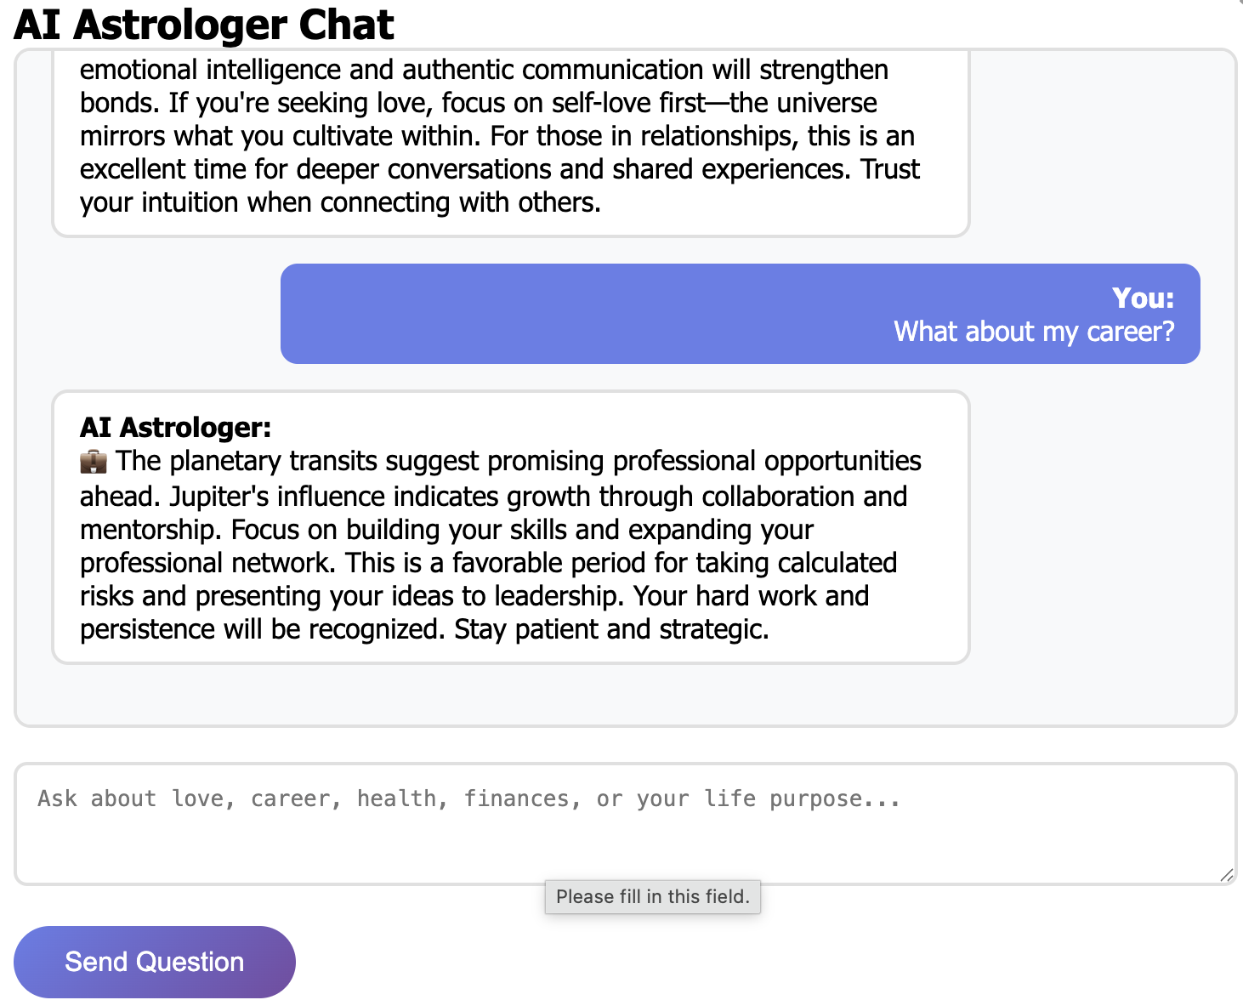
Figure C.5: AI Chatbot - Career Guidance


Figure C.6: Daily Horoscope Zodiac Selection

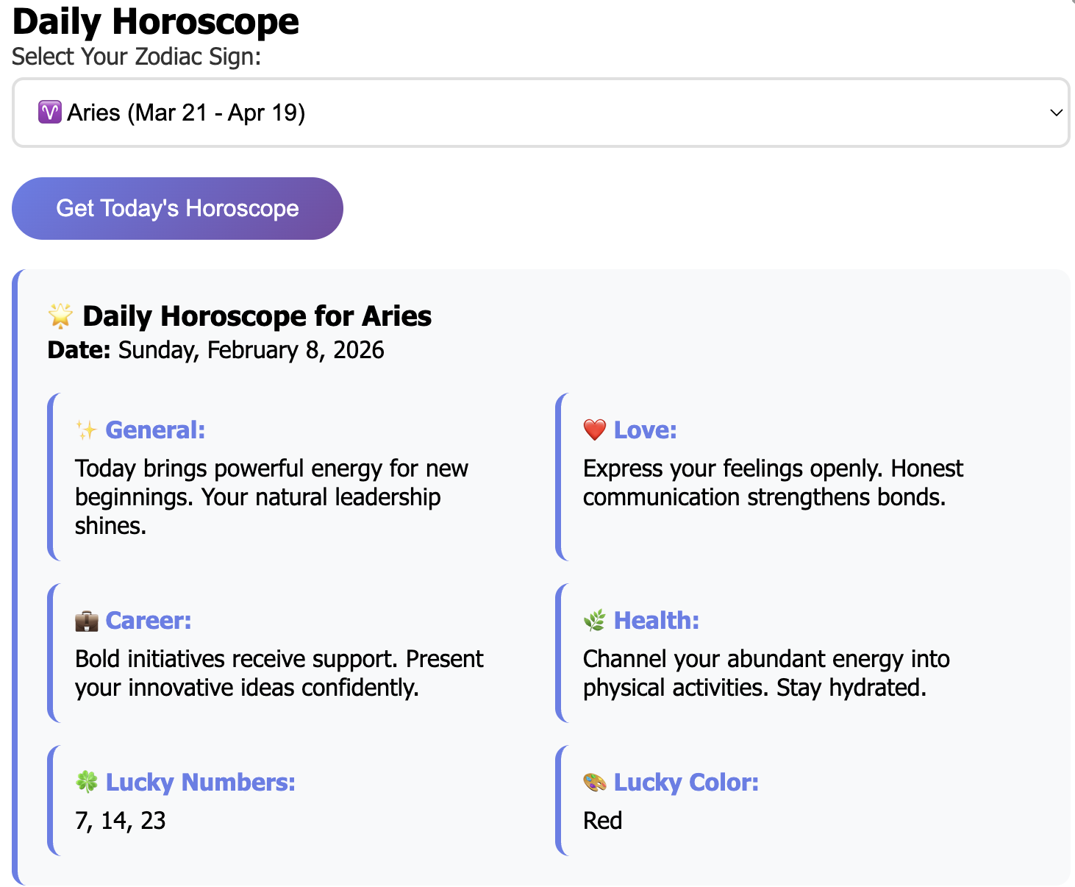
Figure C.7: Daily Horoscope Output for Aries

Appendix D: Acknowledgments
I express my sincere gratitude to Prof. Dr. Rajeev Verma for his guidance and support throughout this research project. I also thank the six users who generously provided their time and honest feedback to help improve Jyoti Darshan. Finally, I acknowledge IIM Ranchi for providing the academic framework and learning environment that made this research possible.

Appendix E: Technical Implementation Details

E.1 Data Flow Architecture
This appendix provides technical documentation of how Jyoti Darshan fetches, processes, and delivers astrological data based on user inputs. Understanding the data flow is essential for evaluating the application's technical feasibility and scalability.

E.2 Birth Chart Data Flow
Step 1: User Input Collection
User provides three critical inputs via HTML form:
• Date of Birth (DD/MM/YYYY format)
• Time of Birth (HH:MM AM/PM format)
• Place of Birth (City name)
Step 2: Geocoding and Coordinate Conversion
The application uses a geocoding API (Google Maps Geocoding API or OpenStreetMap Nominatim) to convert the place name into precise geographic coordinates:
• Input: 'Mumbai, India'
• API Call: GET https://maps.googleapis.com/maps/api/geocode/json?address=Mumbai
• Output: Latitude: 19.0760° N, Longitude: 72.8777° E
Step 3: Astronomical Calculations
Using the Swiss Ephemeris library (either via JavaScript port or API), the system calculates:
a) Julian Day Number: Converts birth date/time to Julian Day for astronomical calculations
b) Sidereal Time: Calculates Local Sidereal Time at birth moment
c) Planetary Positions: Retrieves ecliptic longitude of Sun, Moon, Mars, Mercury, Jupiter, Venus, Saturn, Rahu (North Node), Ketu (South Node)
d) House Cusps: Calculates 12 house divisions using Placidus or Whole Sign house system
e) Ascendant (Lagna): Determines rising sign based on sidereal time and latitude
Example Calculation Output:
For birth on March 3, 1992, 10:30 AM in Mumbai:
• Sun: 18° Aquarius (11th house)
• Moon: 24° Taurus (3rd house)
• Ascendant: 12° Aries (1st house)
Step 4: AI-Generated Interpretation
The calculated planetary positions are sent to an AI API (OpenAI GPT-4 or Anthropic Claude) with a structured prompt:
Prompt Structure: 'You are a Vedic astrologer. Generate a birth chart interpretation for a person born on [date] at [time] in [place]. Sun is in [sign] in house [number]. Moon is in [sign] in house [number]... Provide insights on personality, life path, strengths, and challenges.'
The AI returns natural language interpretation which is displayed to the user alongside the visual birth chart.

E.3 AI Chatbot Data Flow
Step 1: User Question Input
User types a natural language question, e.g., 'Will I get a promotion this year?'
Step 2: Context Assembly
The system constructs a comprehensive context including:
• User's birth chart (if previously generated)
• Current planetary transits (fetched from ephemeris)
• Conversation history (last 5 messages)
Step 3: AI API Call
POST request to AI API with system prompt, user context, and question. System prompt defines the AI's role as a knowledgeable but encouraging astrologer who provides guidance without deterministic predictions.
Step 4: Response Delivery
AI-generated response is displayed in the chat interface with typing animation effect to simulate conversational flow.

E.4 Daily Horoscope Data Flow
Step 1: Zodiac Sign Selection
User selects their zodiac sign from dropdown menu (Aries through Pisces).
Step 2: Current Transit Calculation
System fetches today's date and calculates current planetary positions. For each planet, determines which zodiac sign it's transiting and which house it aspects relative to the user's sun sign.
Step 3: Panchang Data Integration (Future Enhancement)
Planned integration with Drik Panchang API to include: Tithi (lunar day), Nakshatra (lunar mansion), Yoga, Karana, and auspicious/inauspicious timings (Rahukaal, Yamagandam).
Step 4: AI Horoscope Generation
AI generates daily predictions structured as: Overall energy, Love & Relationships, Career & Finances, Health & Wellness, Lucky number, Lucky color, and Daily suggestion.

E.5 Data Sources Summary
External APIs Used:
1. Geocoding API: Google Maps API or OpenStreetMap Nominatim (for coordinate conversion)
2. Swiss Ephemeris: Astronomical calculation library (planetary positions, house cusps)
3. AI API: OpenAI GPT-4 or Anthropic Claude (natural language generation)
4. Panchang API: Drik Panchang (future integration for traditional Hindu calendar data)
Data Processing Flow:
User Input → Geocoding → Astronomical Calculations → AI Interpretation → User Display
Privacy and Data Handling:
Currently, the application operates in stateless mode - no user data is stored on servers. Birth details are processed in-session and discarded after response generation. For future versions with user accounts, data will be encrypted at rest and in transit, with opt-in consent for data retention.

E.6 Technical Limitations Acknowledged
During the pilot testing phase (January 21 - February 3, 2026), several technical limitations were identified:
1. Intermittent API connectivity issues affecting response times
2. Incomplete error handling for invalid birth locations
3. Face Reading feature not fully implemented (placeholder functionality)
4. Limited AI response variety leading to occasional repetitive horoscopes
These limitations are acknowledged in the research findings and did not prevent meaningful user feedback collection. Future development will address these issues through improved error handling, API redundancy, and enhanced AI prompt engineering.

--- END OF REPORT ---

